Corner-shop Data Analysis Manual

Contents

Corner-shop Data Steps: Excel 2

Simple Understanding Using Pivot Tables 2

Queries 6

# Corner-shop Data Steps: Excel

### Simple Understanding Using Pivot Tables

1. open merged excel file
2. open data spreadsheet
3. select all of the data, click insert (next to home) and create a pivot table in a new sheet as shown below. Click OK.

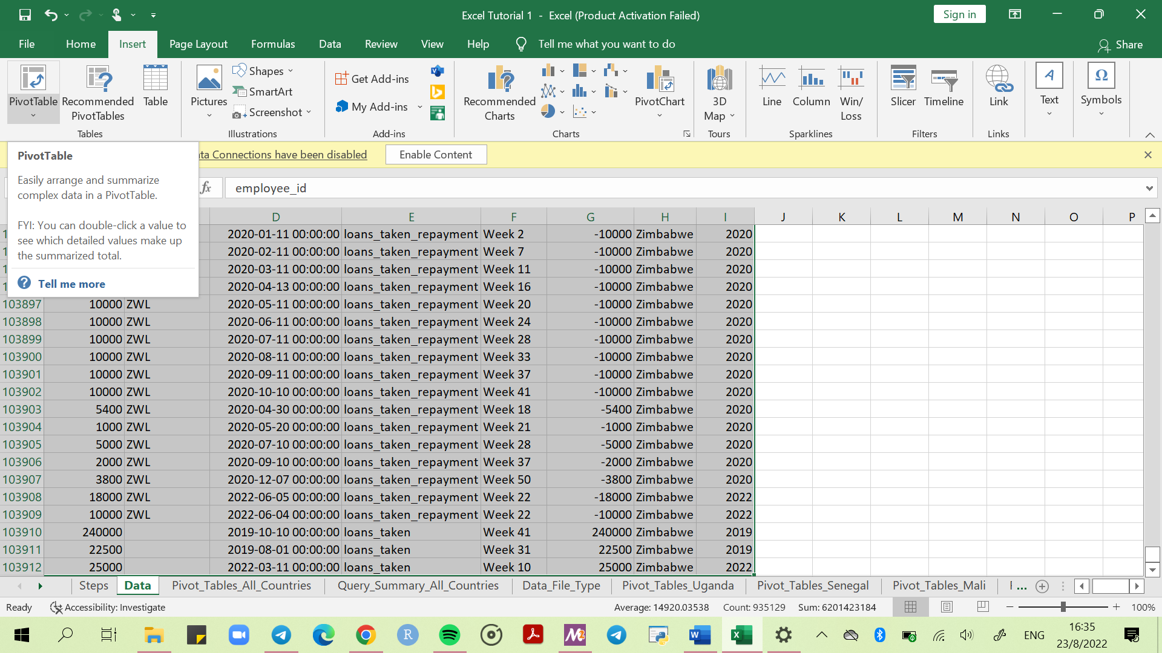

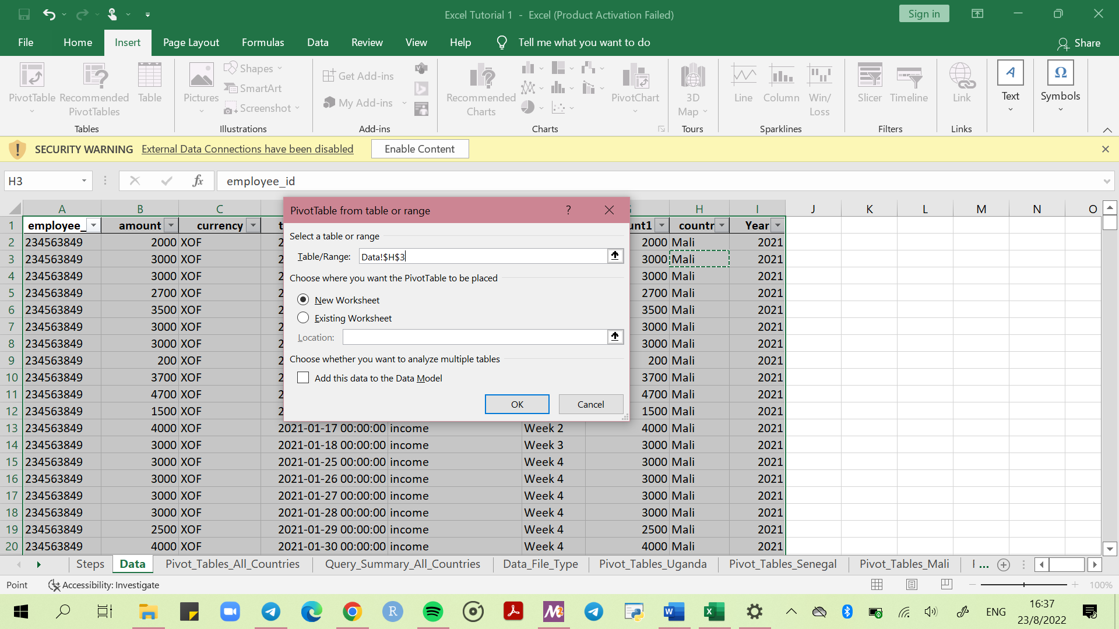

1. A blank pivot table will appear as shown below.

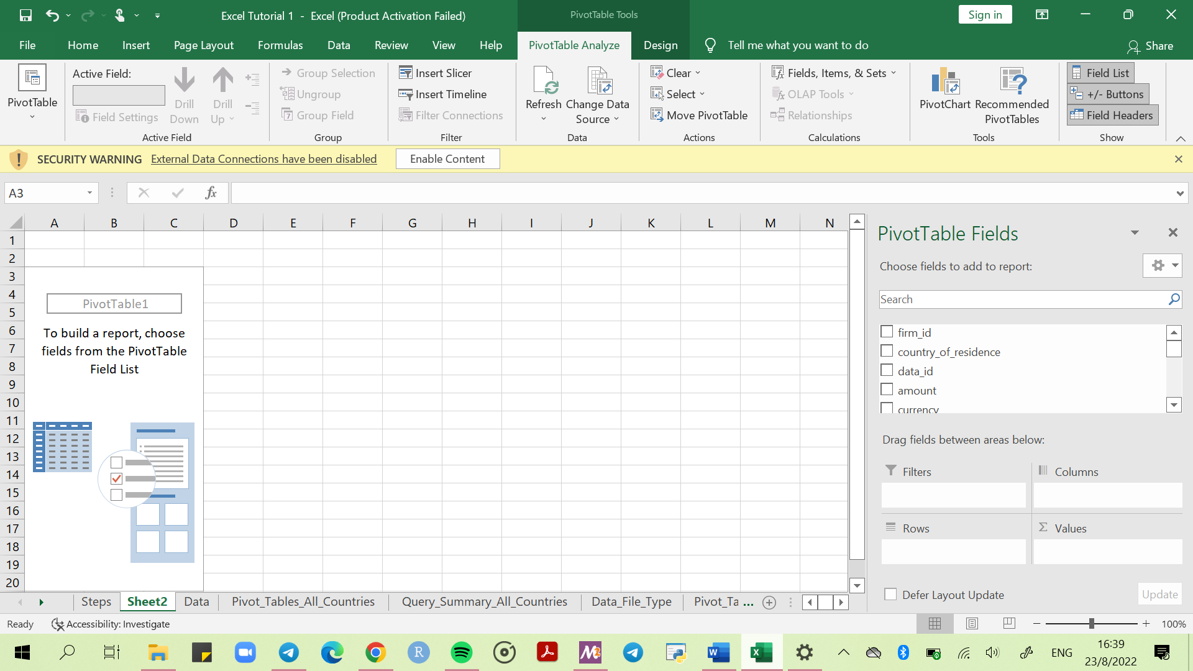

1. Under Pivot Table Fields on the far-right side, use the following settings. (Feel free to adjust settings as needed, depending on the type of analysis. Refer to the image below.
2. **Filters** – what you want to filter the data with. E.g., *Year, Account, Country*
3. **Columns** – what you want in the columns. E.g., *week*
4. **Rows** – what you want in the rows, using the unique identity number. E.g., *firm_id*
5. **Values** – what you want calculated. E.g., *Amount as Sum of Amount*

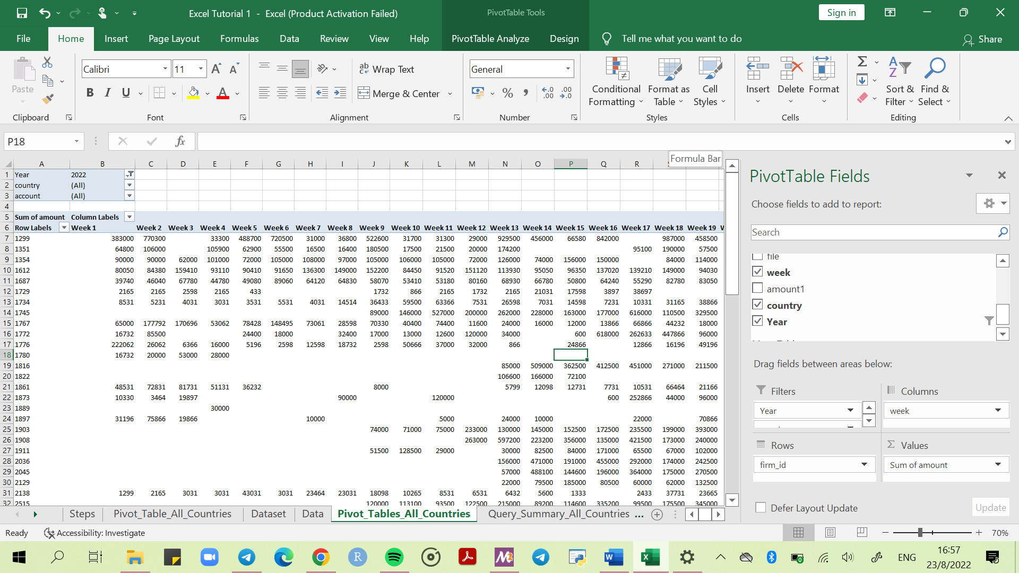

1. Create a new sheet by right clicking next to an existing excel spreadsheet. Click insert, select worksheet on the dialog that appears, click ok. Rename the new spreadsheet to “*Query_Summary_All_Countries*”.

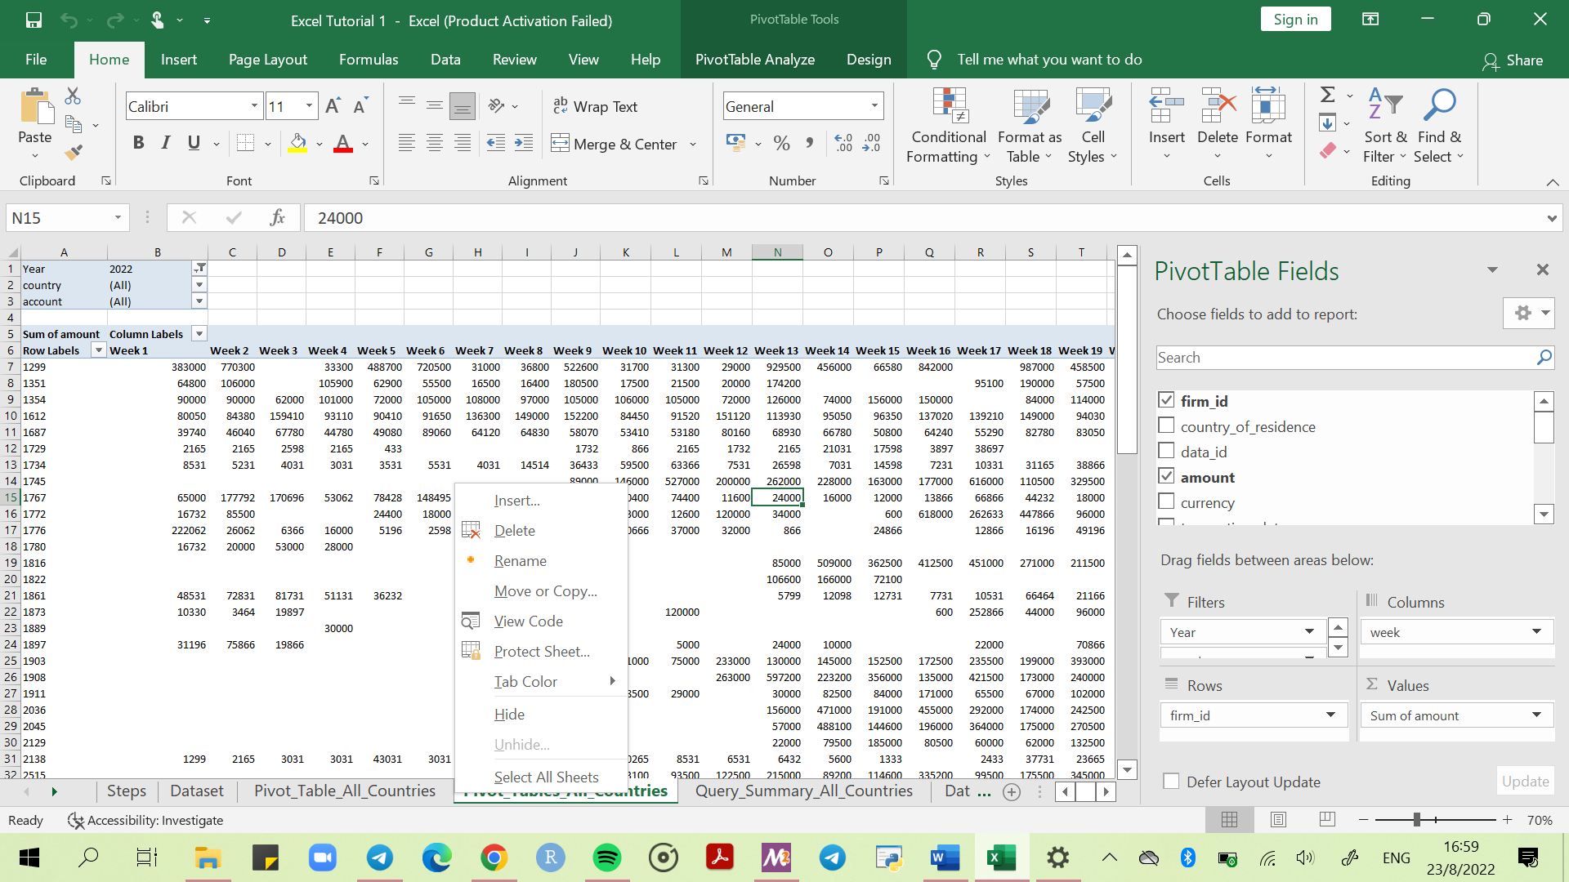

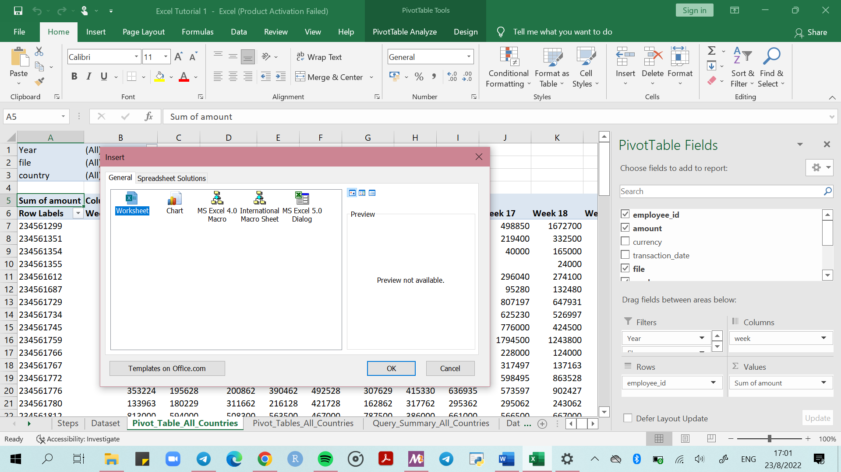

1. Create separate pivot tables for each country by using the filter if needed. Separate pivot tables will make comparison at a glance a lot easier. Refer to images below.

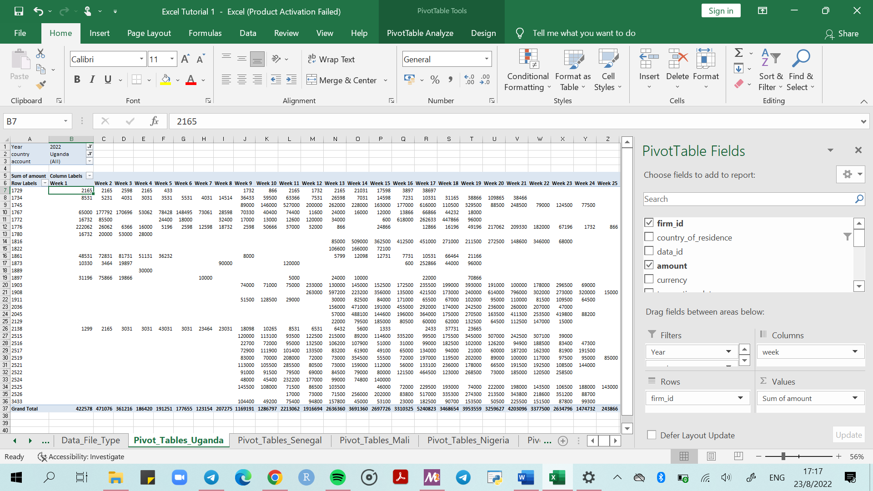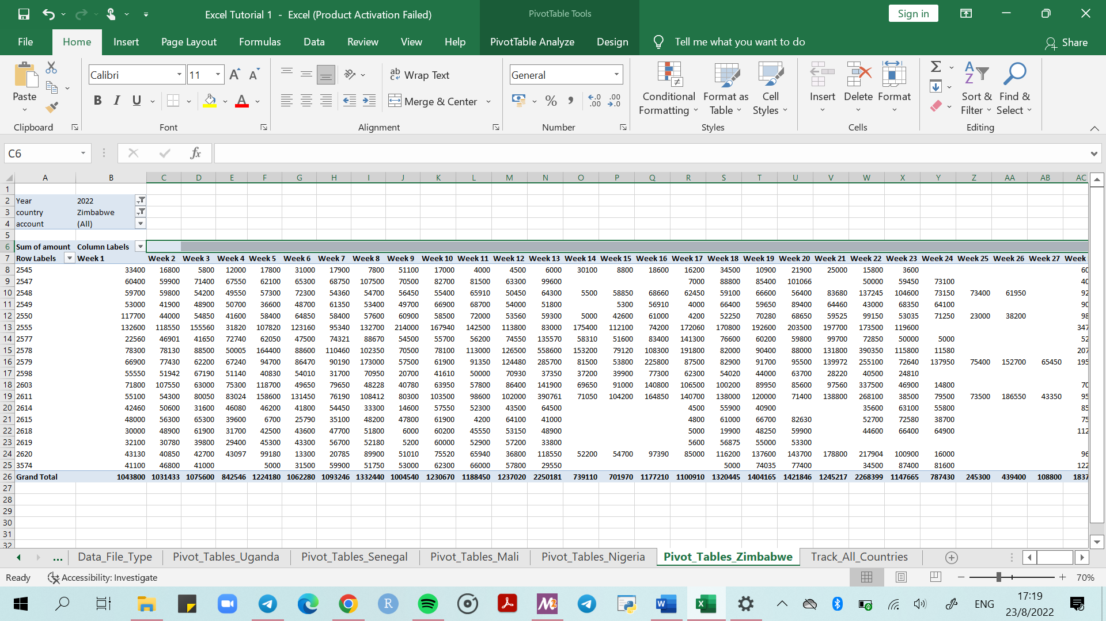

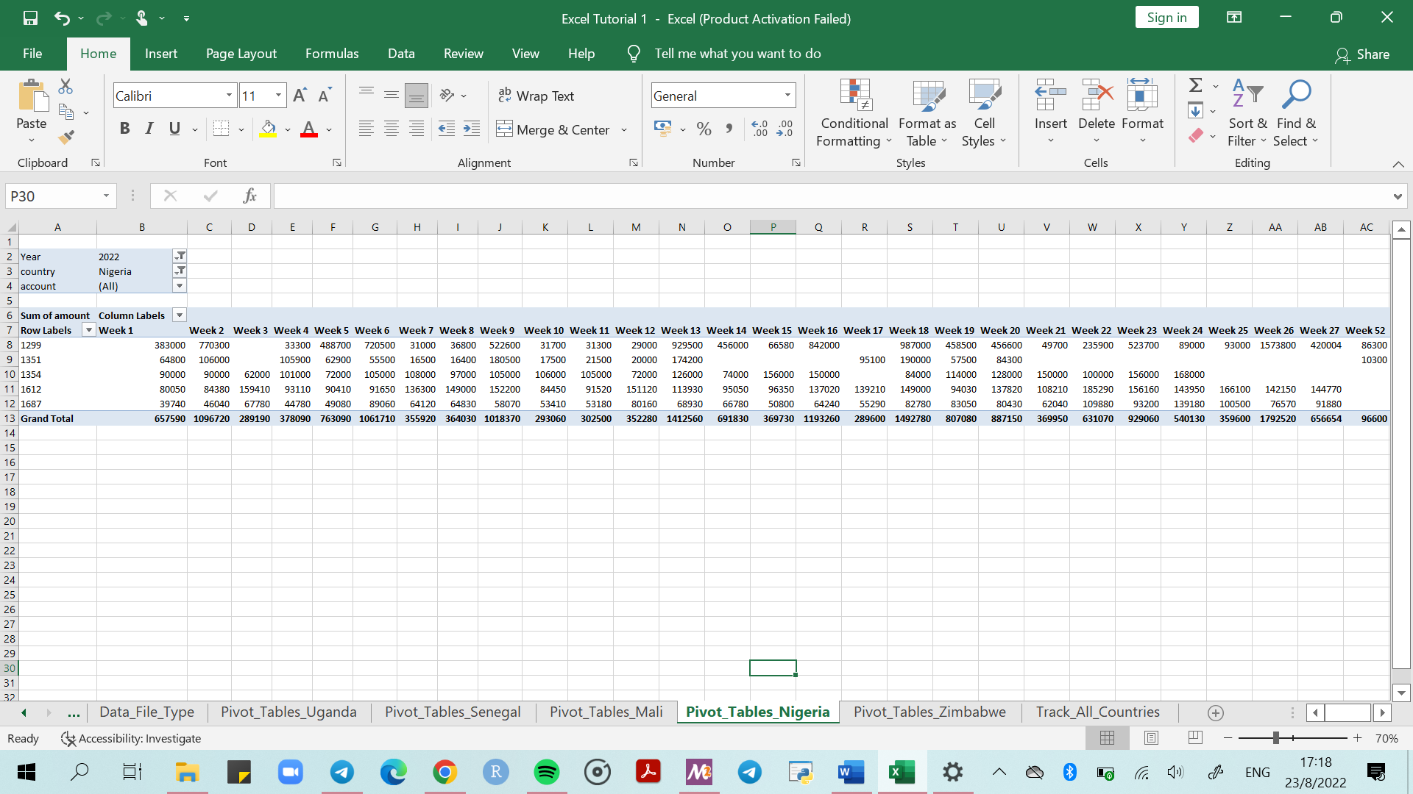

### Queries Using Vlookup, IF, Formulas

1. Highlight all firm-id’s from top to bottom, copy and paste as values into newly created spreadsheet *Query_Summary_All_Countries*

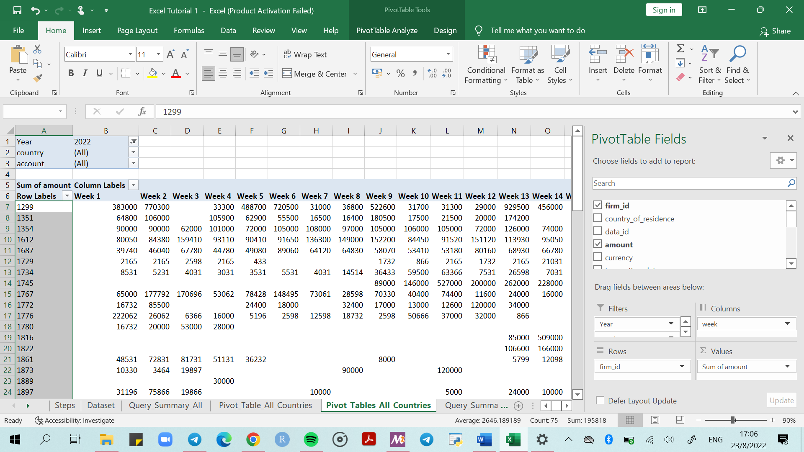

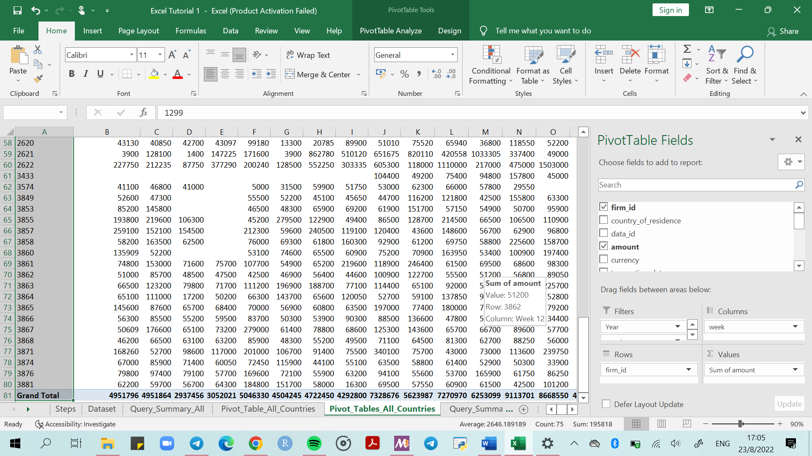

1. Paste the firm id’s onto a new spreadsheet. Paste as values.